Work with github

Prerequesits

Install git local:
Download from Git - Install for Windows
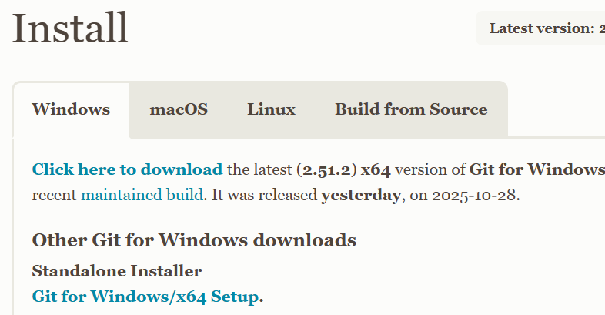

Working with it
After installing you have git bash 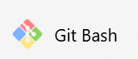, start it.
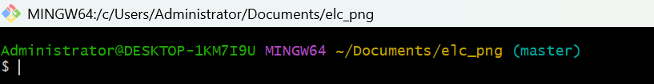
To download existing git repository: (keep in mind it’s not Windows but Linux/Unix style in man things, e.g. / instead of \)
- Create a local directory for this e.g. /c/Users/Administrator/Documents/elc_png
- There add the remote
git remote add origin https://github.com/miwohlf-dot/elc-database/tree/master/deliverables
This points to elc database
- Git clone takes all remote files also to your local directory

After adding or changing some code or document
The red thigs have to be written:
Administrator@DESKTOP-1KM7I9U MINGW64 ~/Documents/elc_png (master)
$ git add .

Administrator@DESKTOP-1KM7I9U MINGW64 ~/Documents/elc_png (master)
$ git commit -m "content out help for form excel to DB added"
[master 2da1c6e] content out help for form excel to DB added
27 files changed, 2 insertions(+), 13517 deletions(-)
create mode 100644 deliverables/Templates/Example to load.xlsx
create mode 100644 deliverables/Templates/~$Example to load.xlsx
delete mode 100644 deliverables/database content/congregation.csv
delete mode 100644 deliverables/database content/elc_seket.csv
delete mode 100644 deliverables/database content/tbl_admin_struc1.csv
delete mode 100644 deliverables/database content/tbl_admin_structure.csv
delete mode 100644 deliverables/database content/tbl_banking.csv
delete mode 100644 deliverables/database content/tbl_dep_pers_rel.csv
delete mode 100644 deliverables/database content/tbl_dependants.csv
delete mode 100644 deliverables/database content/tbl_elc_cong_codes.csv
delete mode 100644 deliverables/database content/tbl_elc_struc1.csv
delete mode 100644 deliverables/database content/tbl_emergency_contact.csv
delete mode 100644 deliverables/database content/tbl_pers_school_rel.csv
delete mode 100644 deliverables/database content/tbl_person.csv
delete mode 100644 deliverables/database content/tbl_residence.csv
delete mode 100644 deliverables/database content/tbl_school.csv
delete mode 100644 deliverables/database content/tbl_service_area.csv
delete mode 100644 deliverables/database content/tbl_spouse.csv
create mode 100644 deliverables/documents/mapping.xlsx
delete mode 100644 deliverables/documents/~$ample Queries.docx
create mode 100644 deliverables/documents/~$mapping.xlsx
delete mode 100644 deliverables/documents/~$rk with github.docx
delete mode 100644 deliverables/documents/~$scription of existing Database Objects.docx
delete mode 100644 deliverables/documents/~WRL0003.tmp
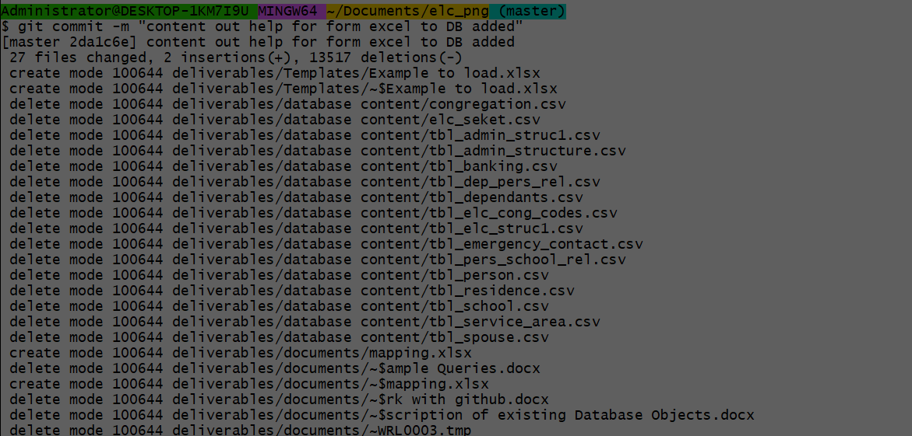
Git push to send it to remote repository
Ready

